Exploratory Testing Notes
Session Info
Field | Details
Feature Under Test | Website (AppTestingService + EchoGPT) Android App (AppTestingService + EchoCHAT)
Tester | Radoanul Arifen
Duration | 35 Minutes
Approach | Unscripted exploration focusing on UI, navigation, authentication, and CTAs
Devices Used | Windows + Chrome / Android 13

Test Charter
Explore the critical user journey including homepage navigation -- pricing tabs -- login -- dashboard and identify UX issues, broken links, and behavior under rapid actions.

Areas Explored
- Homepage CTA buttons (Android / Games / AndroidPro section)
- Login & Forgot Password screen behavior
- Pricing section responsiveness
- Dashboard widget loading & logout flow
- Keyboard access and tab navigation
- Slow internet response & refresh behavior

Observations & Findings
# | Observation | Type | Result | Evidence
1 | “Get Started Now” CTA button in Android section not performing navigation | Functional | Failed | 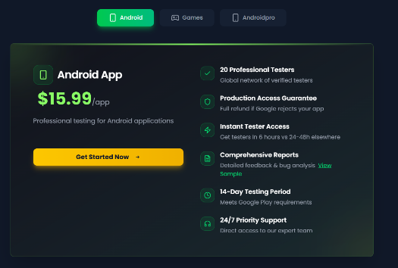
2 | “Get Started Now” CTA button in Gaming section not performing navigation | Functional | Failed | 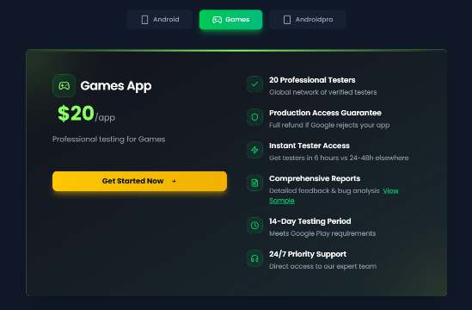
3 | “Get Started Now” CTA button in Androidpro section not performing navigation | Functional | Failed | 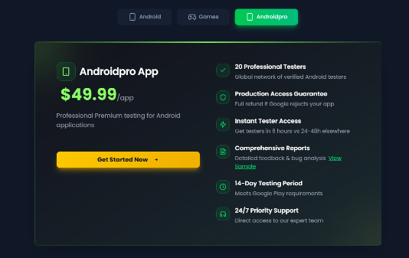
3 | “Forgot password?” link’s wrong alignment below Email field (Get Started Section) | UI/UX | Failed | 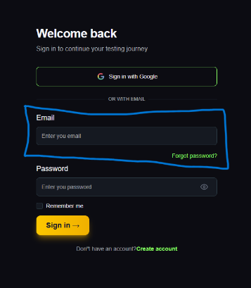
4 | “Forgot password?” link’s wrong alignment below Email field (Login Section) | UI/UX | Failed | 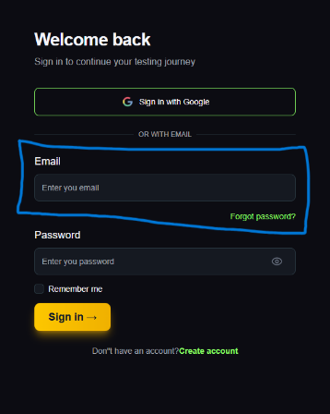
4 | Incorrect apostrophe in “Don’t have an account?” → shows Don”t (Get Started Section) | Content/UI | Failed | 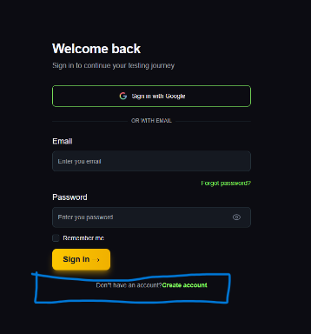
5 | Incorrect apostrophe in “Don’t have an account?” → shows Don”t (Login Section) | Content/UI | Failed | 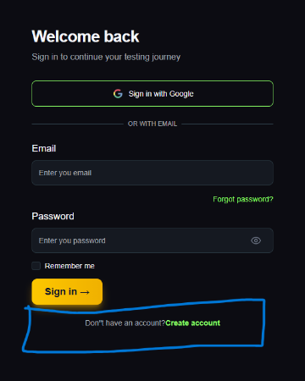
6 | ALT attributes exist for accessibility | Accessibility | Passed | Verified in DevTools
7 | Dashboard widget values well aligned & visible | UI/UX | Passed | Visual confirmation
8 | Browser refresh does not break login session | Stability | Passed | Working fine

Risks Identified
Risk | Impact
CTA not working blocks purchase flow | High
UI misalignment may confuse new users | Medium
Minor text formatting reduces brand quality | Low

Final Exploratory Outcome
Most features are usable and stable,
but Critical CTA button failure needs fix before release.
UI polish is also required on authentication screens.
Recommendation: Fix found bugs -- Perform regression -- Recheck conversion flow

